**SQL-4**

**Date:**

**AIM:** To create DATABASE,TABLES and execute the SQL commands according to the following Query.

**QUERY:Create tables CABHUB and CUSTOMER , write and execute the SQL queries for the given questions and observe the outputs.**

**Table: CABHUB**

|  |  |  |  |  |  |
| --- | --- | --- | --- | --- | --- |
| **Vcode** | **Vehicle Name** | **Make** | **Color** | **Capacity** | **Charges** |
| 100 | Innova | Toyota | WHITE | 7 | 15 |
| 102 | SX4 | Suzuki | BLUE | 4 | 14 |
| 104 | C Class | Mercedes | RED | 4 | 35 |
| 105 | A-Star | Suzuki | WHITE | 3 | 14 |
| 108 | Indigo | Tata | SILVER | 3 | 12 |

**Table: CUSTOMER**

|  |  |  |
| --- | --- | --- |
| **Ccode** | **CName** | **Vcode** |
| 1 | Hemant sahu | 101 |
| 2 | Raj lal | 108 |
| 3 | Feroza Shah | 105 |
| 4 | Ketan Dhal | 104 |

**PROCEDURE:**

**1.** Open mysql software.

**2.** Enter the password.

**3.** Enter the following commands in the mysql prompt, mysql >

**4.** Create Database

**5.** Create table CABHUB(Vcode integer, VehicleName char(20),Make char(10),Color char(10),Capacity integer,Charges integer);

**6.** Insert into CABHUB values(101,'Innova','Toyota','WHITE',7,15);

(Repeat this command with different values to insert all the records in the table CABHUB)

**7.** Create table CUSTOMER(Ccode integer,Cname varchar(25),Vcode integer);

**8.** Insert into CUSTOMER values(1,'Hemant sahu',101);

(Repeat this command with different values to insert all the records in the table

CUSTOMER)

**SQL Commands:**

1. **To display all white coloured vehicles.**

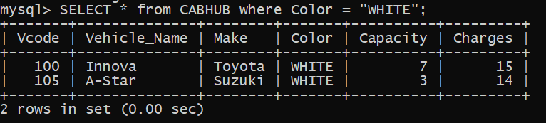

1. **To display the VehicleName , Make and Capacity in ascending order of their seating capacity.**

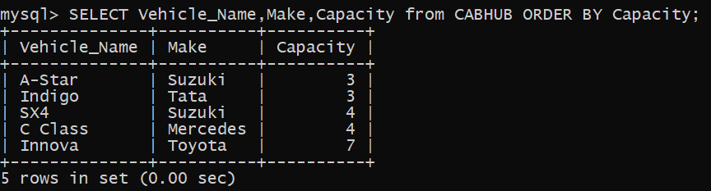

1. **To display the highest charges at which a vehicle can be hired from CABHUB.**

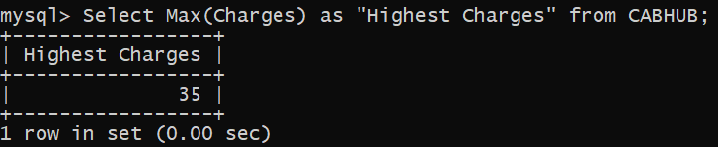

1. **To display the customer name and corresponding name of the vehicle hired by them.**

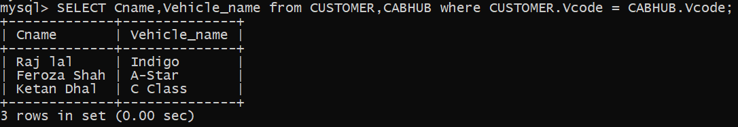

1. **To display the number of make vehicle in the table CABHUB.**

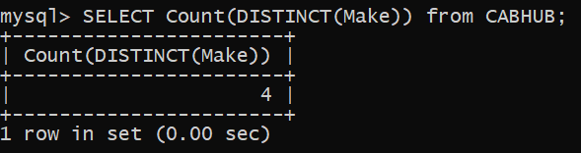

1. **To display the vehicle name, Name of the customer who has hired at the lowest charge.**



1. **To display the number of vehicles based on color from each other.**

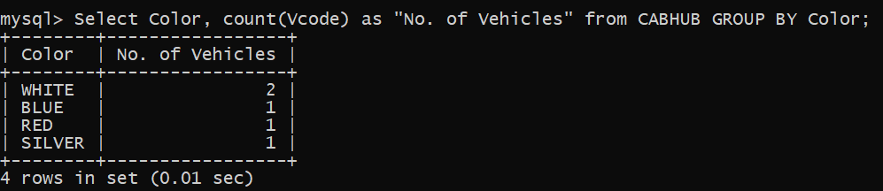

1. **To display the VehicleName whose capacity is 4.**

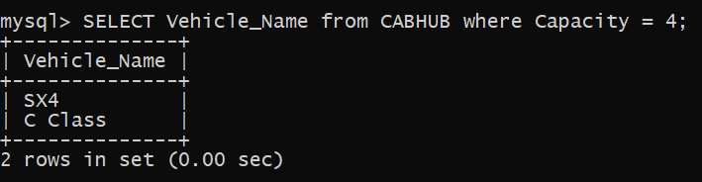

RESULT:

Thus the SQL commands are executed successfully using MYSQL .